**“Kinetic and Potential Energy Calculator” User Guide**

This document guides you in how to use the application “Kinetic and Potential Energy Calculator”.

1. Open the file “kinetic_and_potential_energy_calculator.exe” by going to the folder where that file is saved in after you downloaded it. Below shows how the file icon looks like (see the file circled in red).

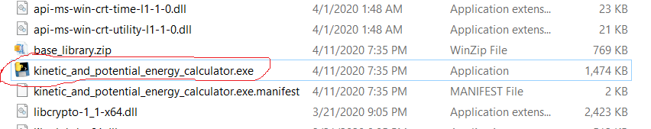

1. Below shows what is initially shown when you have double clicked the application. The text in black is the path to the executable file (which might be different in your PC).

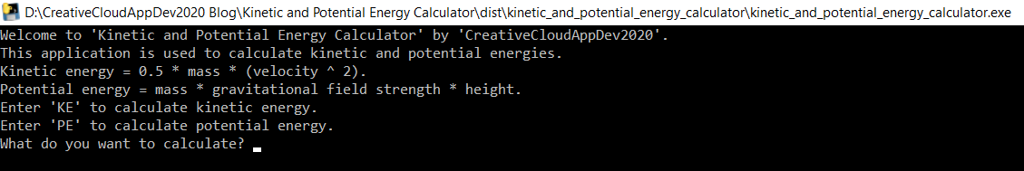

1. If you enter ‘KE’, you will be told to enter the mass and then the velocity of the item. Below shows an example of a calculation of kinetic energy.

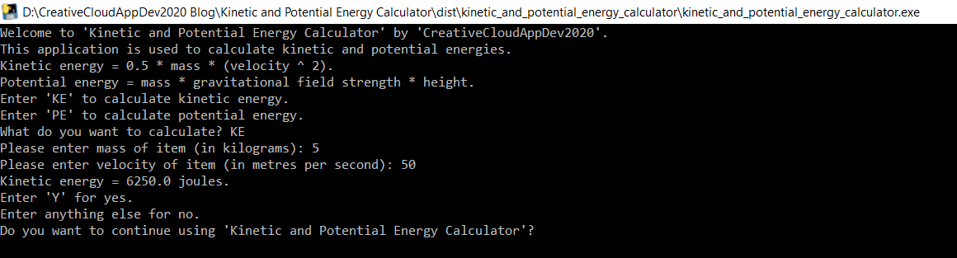

1. If you enter ‘PE, you will be told to enter the mass and then the height of the item. Below shows an example of a calculation of potential energy.

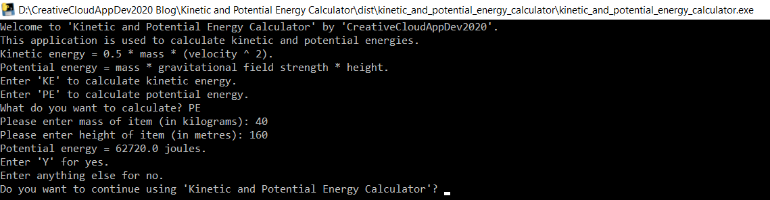

1. Entering anything else when asked “What do you want to calculate?” will show a text notifying that you gave invalid input.

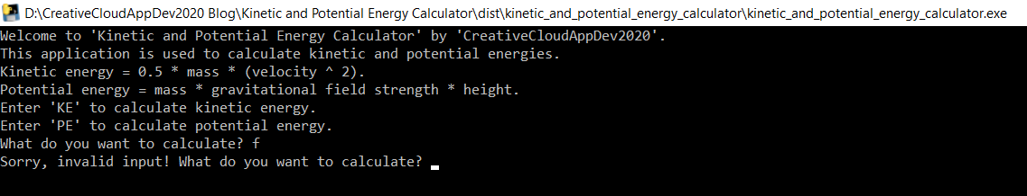

1. The text notifying that you gave invalid input can also appear if you key in a non-number when keying in the mass, velocity, or height of item.
2. When asked “Do you want to continue using ‘Kinetic and Potential Energy Calculator’?”, entering ‘Y’ will redirect you entering what you want to calculate. Entering anything else will quit the application.